## DELHI TECHNOLOGICAL UNIVERSITY, DELHI



## ENGINEERING MECHANICS

## Submitted By:

**Abhinav  
2K20/CE/06**

**Submitted To:**

**Dr.GP Awadhiya**

DELHI TECHNOLOGICAL UNIVERSITY (FORMERLY Delhi College of Engineering) Bawana Road, Delhi-110042

**CANDIDATE’S DECLERATION**

**I**, ( Abhinav 2K20/**CE**/**06**) students of B. Tech. hereby declare that the project Dissertation titled “**Structural Engineering In Historical Buildings And Its Restoration Preservation and Strengthening**” which is submitted by us to the Department of Civil Engineering, Delhi Technological University, Delhi in partial fulfilment of the requirement for the award of the degree of Bachelor of Technology, is original and not copied from any source without proper citation. This work has not previously formed the basis for the award of any Degree, Diploma Associateship, Fellowship or other similar title or recognition.

Place: Delhi Abhinav (2K20/CE/06)

**ENGINEERING MECHANICS**

DELHI TECHNOLOGICAL UNIVERSITY (FORMERLY Delhi College of Engineering)

Bawana Road, Delhi-110042

**CERTIFICATE**

I hereby certify that the project Dissertation titled **“Structural Engineering In Historical Buildings And Its Restoration Preservation and Strengthening”** which is submitted by Abhinav   
( 2K20/CE/06), Delhi Technological University, Delhi in complete fulfilment of the requirement for the award of the degree of the Bachelor of Technology, is a record of the project work carried out by the students under my supervision. To the best of my knowledge this work has not been submitted in part or full for any Degree or Diploma to this University or elsewhere.

Place: Delhi Dr. GP Awadhiya

(Assistant Professor)

Date:

**Structural Engineering In Historical Buildings And Its Restoration Preservation and Strengthening**

1. **ABSTRACT**

The history of structural engineering dates back to at least 2700 BC when the step  
pyramid for Pharaoh Djoser was built by Imhotep, the first architect in history known. Pyramids were the most common major structures built by ancient civilizations. The ancient Romans made great bounds in structural engineering, pioneering large structures in masonry and concrete, many of which are still standing today. They include aqueducts, thermae, columns, lighthouses, defensive walls and harbour.

In India during the first to the third century saw rise in the number of temples built and later during the bhakti kaal many temples were constructed. These temples till now are the masterpiece of Architecture and Structural engineering. These stable structures reflect the amount of engineering knowledge of architects of that time. Later in the Mughal Period we saw an increase in architecture as many masterpieces were built during this period such as The Humayun Tomb, Taj Mahal, Red Fort etc. I will discuss structural engineering used in temples of ancient India and Taj Mahal. As we know that these buildings are not merely a building they are a sneak peak in the past, they reflect our culture and also inspire future architecture. Therefore it is necessary that we preserve and restore these buildings. In this report we will discuss some methods and concepts of structural engineering that may prove vital in restoration of these old buildings.

**ACKNOWLEDGEMENT**

In performing our major project, we had to take the help and guideline of some respected persons, who deserve our greatest gratitude. The completion of this assignment gives us much pleasure. We would like to show our gratitude Dr. GP Awadhiya, Mentor for major project. Giving us a good guideline for report throughout numerous consultations. We would also like to extend our deepest gratitude to all those who have directly and indirectly guided us in writing this assignment.

Many people, our classmates and team members itself, have made valuable comment suggestions on this proposal which gave us an inspiration to improve our assignment. We thank all the people for their help directly and indirectly to complete our assignment.

In addition, we would like to thank Department of Civil Engineering, Delhi Technological University for giving us the opportunity to work on this topic.

**2.Structural Engineering In Ancient Temples**India is a land of saints and spirituality, nature, art and culture; not only so in past the land

was rich in economy also. The land was rich in terms of not only its culture but also for the construction. Probably India was the land of ‘Engineering’ artists. Here, the old temples and forts have resisted the vagaries of the weather for centuries and they are the evidences of this statement. These temples have sustained floods, earthquakes, heavy winds with a very stable response; not only so a few temples have sustained the bombing by foreign armies in past and recently blasts, terrorist attacks etc. exhibiting stubborn design principles. In those days – architecture, planning, budgeting, designing, manufacturing and construction everything used to go hand in hand. Thousand years back, when these temples were built, there were no

established Design principles, testing methods, software, calculators, and spreadsheets etc. were available. Still the end results exhibited by these temples are fabulous engineering performance in terms of forces, deflection, cracking etc. Thus these ‘Vastus’ are really ‘Structural Engineering Marvels’. India has many temples which are as old as 1000yrs or even more. As we know, mainly these temples were the places for spiritual practices / pilgrimage; but apart from that many temples were also used for education, accommodation and political movements. Mostly the temples were built in stone, with limited use of timber and metal mainly for carving and architectural details. Strong stones viz. sandstone,

basalt, marble was given a first choice. The main construction used to be placed on a stable soil, on the massive foundation block.

The plinth level used to be of 6 feet height or even more than that. The foundations

used to be dug deep below the existing ground level. To avoid seepage of water to the

foundation, and even to facilitate the visitors to move around / encircle the temple, stone

paving used to be provided on the periphery of the main temple. The paving used to keep the

growth of large trees and shrubs away from the main temple, and thus helped to protect the footing. On the massive foundation-plinth block the workers used to place strong pillars to

withstand the entire vertical loads of the roof. The central dome used to be supported using

solid stone walls on the periphery of the dome. Often these pillars (columns) used to be derived out from a single piece of stone.

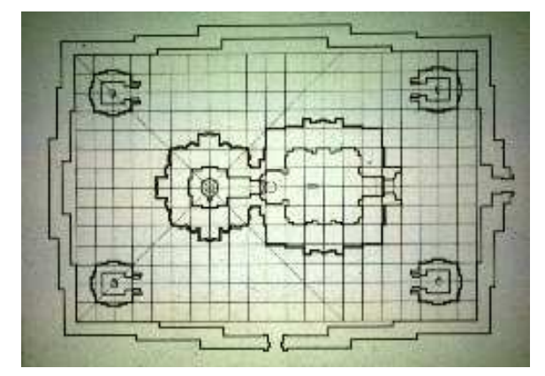

Indian temples constructed using seasoned wood could have longer beam spans as timber has lesser weight and better performance in flexure as compared to stone. On the main beam seating on the corbel, secondary beams / slab panels used to be placed in stone or timber to form the roof enclosure. Lightweight stones like slate or shell were preferred more. The stone roof used to have even cantilever projection at the outer boundaries of the temple, the flexural moment at the end of the cantilever used to be resisted by burring the support under heavy dome / walls on the top of the roofs.

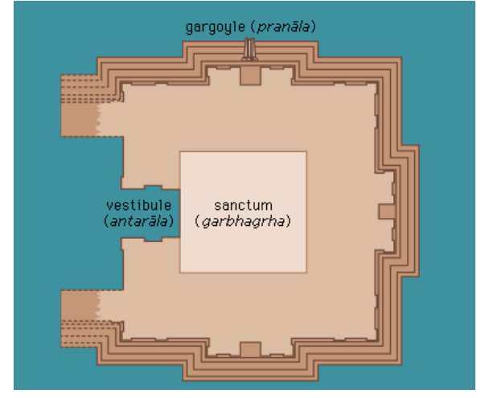

In the olden days, the plan of temple used to be always symmetric. The strong walls of the innermost chamber from the deity and the outer chamber supported on the heavy columns can

be seen clearly from this plan. During earthquake the solid stone walls of the inner chamber used act somewhat like a ‘shear wall’ and helped to perform better. Minars / Shikhars / Domes are found to be of about 200 feet or more height. It is a matter of investigation that how the masons would have erected the pieces so perfectly at this height and matched them! Study of many stone domes shows that the joinery was done using lime, resins or similar matter. But the key stone was kept very tight yet attractive.

**In absence of intricate mathematics how the olden masons / workers were successful to quantify the structural behaviour, is the unsolved question?**

**3.TAJ MAHAL- A Structural Wonder**

The Taj Mahal in one of the finest architectural monuments of the world and has been included in the cultural treasures of the world heritage. It is an ivory-white marble mausoleum on the right bank of the river Yamuna in the Indian city of Agra. The tomb is the central focus of the entire complex of the Taj Mahal. It is a large, white marble structure standing on a square plinth and consists of a symmetrical building with an arch-shaped doorway topped by a large dome and finial. The base structure is a large multi-chambered cube with chamfered corners forming an unequal eight-sided structure that is approximately 55 metres (180 ft) on each of the four long sides. Each side of the iwan is framed with a huge pishtaq or vaulted archway with two similarly shaped arched balconies stacked on either side. Four minarets frame the tomb, one at each corner of the plinth facing the chamfered corners. The most spectacular feature is the marble dome that surmounts the tomb. The dome is nearly 35 metres (115 ft) high which is close in measurement to the length of the base.

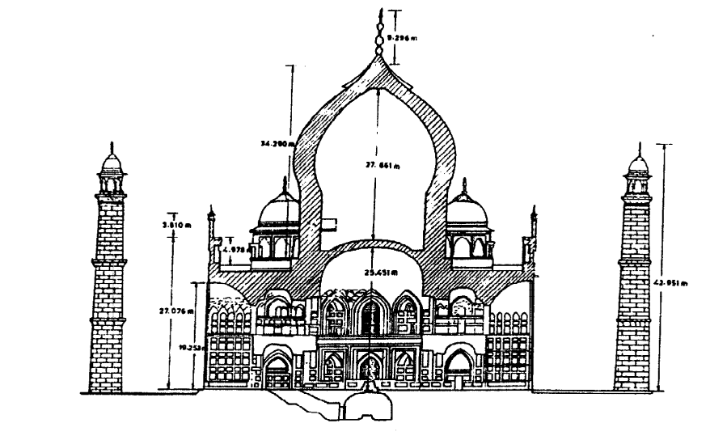

Dynamic analysis of the monument has been carried out for two simplified 3D mathematical models (1) fixed base and (ii) flexible base conditions. The first model is considered fixed at the center of raft while other is considered to be resting on soil springs.

The raft foundation is solid square platform measuring approximately 100m x 100m in plan and 35m thick. The portion of the raft above the ground level is about 18m. The raft is built in brick masonry consisting of thick fire burnt clay bricks and mortar joints of varying thickness.

**Material Properties of Taj Mahal**

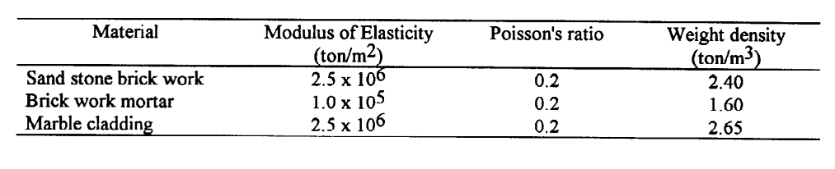

Based on the dynamic analysis carried out for the Taj Mahal monument, the free vibration characteristics and seismic response for bending moments, bending stresses, torsional moments, shear forces and axial forces have been studied and are presented here. A comparative study of structure with fixed base and spring base has also been made.

**Time Periods for the complete structure for fixed and flexible base conditions**

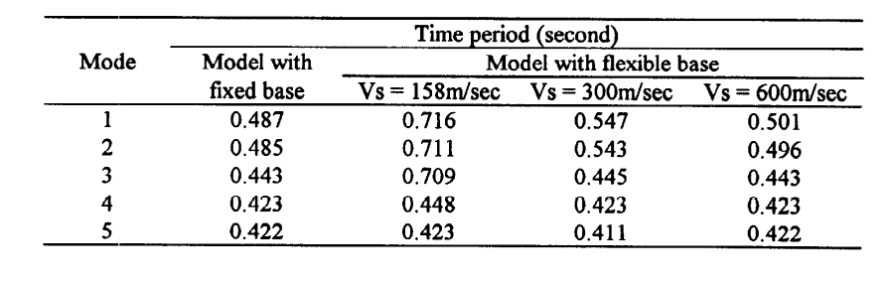

**Displacement at critical Locations in X-direction at code spectra**

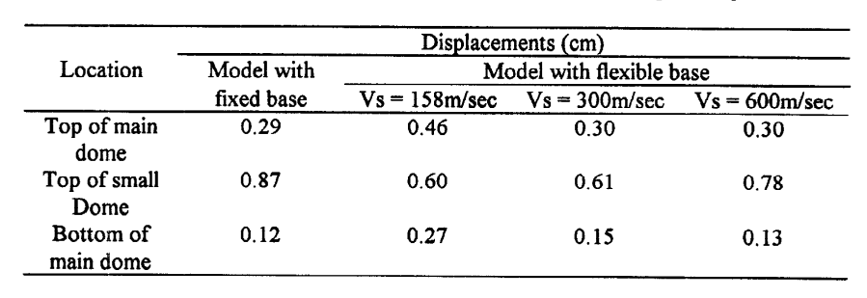

**Bending stresses at critical sections using code spectra**

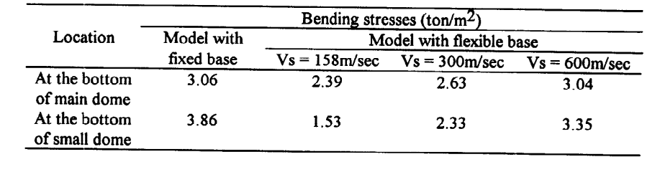

The paper describes various aspects of 3D seismic analysis and safety evaluation of Taj Mahal monument with the aim of retrofitting of structure for future earthquake. The influence of variation of soil properties on seismic response has been particularly studied. It is found that bending stresses in the domes are much smaller for soft soil conditions as compared to fixed base situation.

Taj Mahal is one of the world’s seven wonders. It seems the amount of engineering, planning and construction done even at that time is mesmerising. Even nowadays we could not think of building a monument like Taj Mahal is possible. So to protect this wonder and preserve it for future generations as it is the possession of coming generation, need to study its properties, its construction and threats which are danger to this white marvel. Therefore restoration and preservation seem inevitable if we need to protect Taj Mahal. In the next section we will ponder over the development, techniques and studies used in preservation and restoration.

**4.** **Restoration and Strengthening of Historical Buildings**

A large number of diverse historical buildings in the world require restoration. Due to the demand for their great seismic resistance, as well as for other reasons, there is a need to strengthen their structures. As historical buildings are particularly complex and require detailed preservation of their original historical forms (architectural, artistic, structural, etc.) and also their building materials, the restoration and strengthening of historic buildings are extremely complex and demanding. It particularly refers to the restoration and strengthening of load-bearing structures of historical buildings, presenting a major challenge for structural engineers.

Historical buildings are predominantly built of stone and brick, i.e., their structures are predominantly masonry. Due to the mechanical characteristics of such materials and load-bearing structures of masonry elements, while taking into account the many restrictions required by architectural, conservational, and other objective requirements, the restoration and strengthening of historical buildings can be performed only by experienced and creative structural engineers. The restoration of historical buildings includes the renovation of their various original solutions in terms of shape and size, architectural style, construction, bearing structures, materials, functionality, aesthetics, etc. Numerous historical buildings have been built throughout long years, with various forms, construction styles, building materials, supporting systems, and purposes. Some of the historical buildings have been subjected to severe actions during the years, which have significantly altered their original purpose, load-bearing structure, and appearance. The construction of new buildings or interventions nearby some historical buildings, significantly affected the safety and sustainability of historical buildings in some cases.

In seismically active areas, the historical masonry buildings have often been subjected to numerous strong and sometimes devastating earthquakes. This often led to severe damages or collapse of such buildings because their builders did not predict such actions, namely, the earthquake causes large horizontal forces which produce large bending and shear in the vertical structural elements of the masonry building. In order to reduce the seismic forces on buildings and the stresses in the soil below foundations, in many cases, the experienced builders use lightweight materials of lower strength in higher parts of the building and heavy materials with greater strength in lower parts. So the lower parts in many historical stone structures are made of high-quality stone blocks with larger volume weight and the taller parts of porous less resistant blocks with small volume weight . Because of the simplicity and faster construction, the size of stone blocks is regularly reduced through the height of the building. The use of stones with less volume weight in the arch structures was often motivated by the need for a simpler scaffold in their construction.

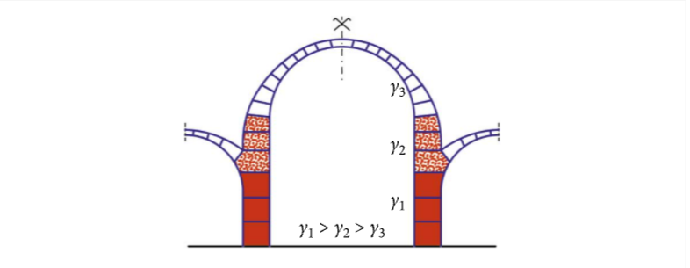

It should be noted that the bearing ability of the masonry walls and columns subjected to shear and bending, i.e., carrying horizontal forces, directly depends on the size of the axial compressive force in them. If it tends to zero, their shear and bending bearing capacities disappear. In case of the increased horizontal force on the walls/columns, they should have higher compressive axial force and greater stiffness. Thereby, it should be ensured that the allowable compressive bearing capacity of the wall and the soil is not exceeded.

* In many historical masonry structures, a lime mortar was used for the joints between masonry elements. Numerous historical buildings have been restored being completely or partially repaired by cement-lime mortar or even pure cement mortar, considering that such buildings will be more resistant to earthquakes and more rigid for other loads and actions.
* Uniform and nonuniform temperature variations in a masonry structure are common cause of cracks and damages, especially when the building is larger and stiffer. In this regard, the dry joints between masonry elements are more favourable because they can deform more freely in different directions. When the mortar is used for joining the masonry elements, exceeding the tensile strains/stresses in the joints due to temperature variations, it can lead to the cracks in the joint. Hence, the cement mortar was also less favourable than lime mortar.

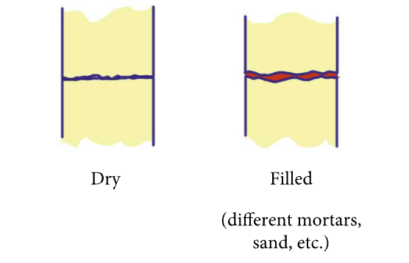

* For the restoration of historical masonry structures, the materials and elements with significantly different temperature coefficients in relation to those of the masonry are sometimes used. If they are coupled, temperature variations may cause unexpected and undesirable damage of the original masonry structure. As a general rule, the coupling of such materials/elements for the classical masonry structures should be avoided.
* The stone columns are often present in numerous historical masonry buildings. such columns are damaged by earthquakes, due to material degradation over time, temperature changes, etc. Their restoration is usually complex and demanding. Short columns are often constructed from a massive block, and tall columns from several blocks called multidrum columns.

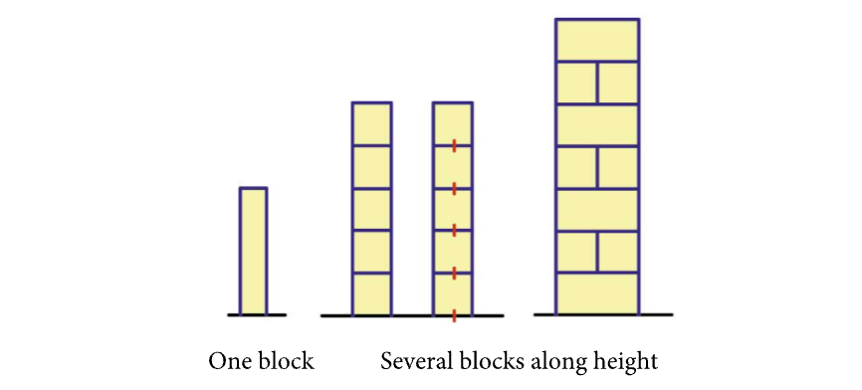

* Many historical buildings have a wooden roof structure . It is particularly desirable that its structure system does not transfer the horizontal forces to the substructure under dead and live loads. It is also desirable that the wooden structure be stiff in its plane and protected from moisture and pests.

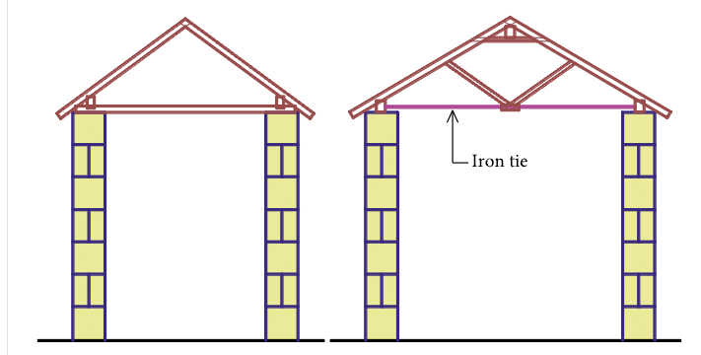

**5. Conclusion**

First we discussed about the presence of structural engineering throughout the ancient and the medival history. We discussed about ancient temples and world wonder white mausoleum The Taj Mahal. We discussed how it is possible to make such stable and magnificent structures. Then we discussed about restoration techniques their flaws and new developments in these techniques.

Indian Archaeological department, civil and structural engineers, common citizens, local

authorities have done handsome job to Identify and preserve this ‘Structural Engineering

marvels’. But still they need to be studied in more depth from ‘mathematical’ and ‘Structural

Analysis’ and ‘Design’ point of view. Also, in absence of modern concepts like durability, ductility, performance, strength, stiffness, flexibility etc. how the material has sustained for so many years.

The structural restoration of each historical building is specific, both in a global solution and in the solutions of particular details. Therefore, it is first necessary to study its basic properties and analyse its deficiencies and damages and examine the properties of the basic materials. In this respect, it is important to carry out a detailed range of necessary field and laboratory works. Only after the completion of the necessary analysis, all the appropriate solutions of restoration/rehabilitation/reconstruction of buildings can be defined and developed, and then all adequate computational verifications and evidences can be carried out.

**At last we draw a conclusion that these historical buildings are necessary for future generations and with correct restoration techniques and analysis of data like stress, strain, strength, compressibility etc. We can clearly preserve them for future and all the stake holders such as Governments, institutions and Citizens all realise our duty and work towards the preservation of these ancient engineering marvels**.

**6.References**

* <https://en.wikipedia.org/wiki/Taj_Mahal>
* <https://en.wikipedia.org/wiki/History_of_structural_engineering>
* Indian Temples – CBS publisher, New Delhi
* Various other websites
* Data on internet